JOY OF COMPUTING USING PYTHON

Experiment-1

Date:10/09/2018

**Objective**:Write a program to implement merge sort algorithm using recursion.

**Code**:

import random

def merge_sort(any_list):

length = len(any_list)

if length == 1:

return any_list

list_1 = any_list[:length//2]

list_2 = any_list[length//2:]

list_1 = merge_sort(list_1)

list_2 = merge_sort(list_2)

return merge(list_1, list_2)

def merge(list_1, list_2):

temp = []

while len(list_1) != 0 and len(list_2) != 0:

if list_1[0]<list_2[0]:

temp.append(list_1[0])

list_1.pop(0)

else:

temp.append(list_2[0])

list_2.pop(0)

if len(list_1) ==0:

flag = 0

else:

flag = 1

if flag ==0:

temp = add_remaining(temp, list_2)

else:

temp = add_remaining(temp, list_1)

return temp

def add_remaining(temp, any_list):

for i in any_list:

temp.append(i)

return temp

def generate_list(n):

return [random.randint(1,9) for i in range(n)]

def solve(any_list):

print("List before sorting :", any_list, "\nList after sorting:", merge_sort(any_list),end="\n\n")

solve(generate_list(10))

solve(generate_list(10))

Output :

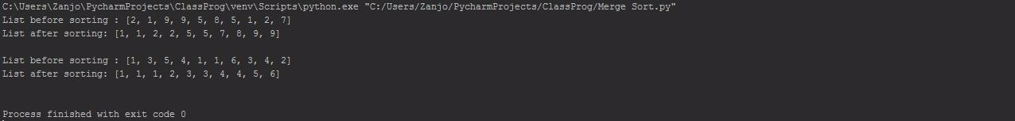

Experiment-2

**Objective**:Create a class and insert the details of the students such as name , subject and marks and find the average marks of the students in all the subjects .

**Code**:

class Student:

def __init__(self, name,**kwargs):

self.subjects = {}

for subject, marks in kwargs.items():

self.subjects[subject] = marks

self.name = name

def add_subjects(self,subject, marks):

if subject in self.subjects:

print(subject,"has already been added to the subjects list of the student!")

return

self.subjects[subject] = marks

def find_average(self):

temp = 0

for marks in self.subjects.values():

temp+=marks

return "Total Marks Scored: "+str(temp)+"\nAverage marks scored: "+str(temp/len(self.subjects))

def __str__(self):

s = "-----Student Details-----" +"\nName: "+self.name+"\nMarks secured in each subject(s):"

for subject, marks in self.subjects.items():

s+="\n"+subject+" = "+ str(marks)

return s

Clay = Student("Clay Jensen",Geography=96, English=92, History=88 )

print(Clay)

print(Clay.find_average(),"\n")

Katherine = Student("Katherine Langford",Maths=96, Physics=88, Biology=84)

Katherine.add_subjects("Chemistry",92)

print(Katherine)

print(Katherine.find_average())

OUTPUT: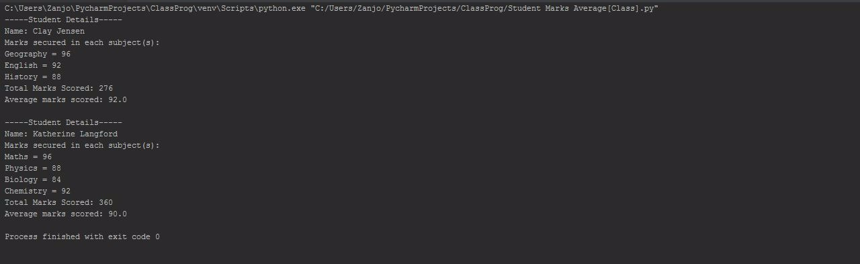

Experiment-3

**Objective**:Create a class and enter the details of three sport events.Take input from user.Use 3 classes for three sport events.

**Code**:

class Sports:

def __init__(self, number_of_players, venue, registration_open):

self.number_of_players = number_of_players

self.venue = venue

self.registration_open = registration_open

def details(self):

print("Number of registered players:", self.number_of_players)

print("Venue of the event:", self.venue)

print("Registration Open:", self.registration_open)

class TableTennis(Sports):

def __init__(self, number_of_players, venue, registration_open):

Sports.__init__(self, number_of_players, venue, registration_open)

def details(self):

print("*******GAME DETAILS*******\nGame: Table Tennis")

Sports.details(self)

class Badminton(Sports):

def __init__(self, number_of_players, venue, registration_open):

Sports.__init__(self, number_of_players, venue, registration_open)

def details(self):

print("Game: Badminton")

Sports.details(self)

class Squash(Sports):

def __init__(self, number_of_players, venue, registration_open):

Sports.__init__(self, number_of_players, venue, registration_open)

def details(self):

print("Game: Squash")

Sports.details(self)

def get_values(game=""):

temp = list()

print("Enter the game details for "+game+":")

temp.append(int(input("Enter the number of registered players: ")))

temp.append(input("Venue of the event: "))

flag = int(input("Is the registration still open(0/1): "))

if flag == 0:

temp.append(False)

else:

temp.append(True)

return temp

data = get_values("Table Tennis")

game_1 = TableTennis(data[0], data[1], data[2])

print()

data = get_values("Badminton")

game_2 = Badminton(data[0], data[1], data[2])

print()

data = get_values('Squash')

game_3 = Squash(data[0], data[1], data[2])

print()

game_1.details()

print()

game_2.details()

print()

game_3.details()

OUTPUT:

